Thank you for joining Presto English CELPIP Training Session.

Please take a moment to read the following important details:

* Complete each exercise by the end of each day. Answer key will be provided the following day.
* Upload your written answers through this link <http://bit.ly/myCELPIP> (you need to enter your name and email address).
* **For the speaking exercise**, post your audio file on the telegram chat room. It’s highly beneficial to study together in a group, so do not be afraid to share your speaking response with others. This is a valuable opportunity to learn from one another.
* If you have questions, please ask your questions in the chat room, as others may have the same questions.

All documents and information provided as a part of this training session are intended only for the individual to which they are originally given. Further distribution, duplication, or use is an infringement of the copyright policy.

Please do not share/re-upload the content without permission from Presto English. Thank you for your cooperation.

CELPIP Training © 2019 Presto English Learning  
 <https://www.youtube.com/prestoenglish>

**Each sentence contains grammatical error(s). Fix the errors to make it grammatical.  
These sentences are adapted from the sentences in your assessment test.**

1. A smartphone, which I find very important for my work, continuously send signal that travel miles away.  
   Click here to enter text.
2. The most convincing evidence of the murder that the police found the suspect’s fingerprints all over the glasses.  
   Click here to enter text.
3. The reason is because I had no money to buy what he want.  
   Click here to enter text.
4. The hotel has three main towers consist of 100 rooms each.  
   Click here to enter text.
5. He persuades his parents financing his business venture.  
   Click here to enter text.
6. Once the production is complete, the goods will send to the distribution centre.  
   Click here to enter text.
7. Even though the rain continue to pour, search team didn’t stop the rescue mission.  
   Click here to enter text.
8. This year, the competition will hold in Edmonton.

Click here to enter text.

1. Starting your own business require careful preparation, a lot of patience, and, at times, must be willing to take risk.Click here to enter text.

CELPIP Training © 2019 Presto English Learning  
 <https://www.youtube.com/prestoenglish>

**Complete each sentence by using words that you learned in Day 1-3 Vocabulary Sheet**

1. Not only did I miss my bus, I also lost my wallet on my why there. It's so _______ when we have such bad luck.
2. I have to say that the advantages clearly _______ the disadvantages.
3. This is just a temporary _______ until we find a permanent solution.
4. I know this is not what you want to hear, but I don't want you to _______ getting hurt **later**.
5. I've _______ your proposal, but I have some problems with it.
6. The decision _______ what’s the most economical. It’s as simple as that.
7. You're talking to the wrong person. He is not _______ handling the money transfer.
8. I understand that you are _______ the flight cancellation. Please allow me to explain.
9. I am not too _______ going to the beach. I prefer going shopping.
10. I had been _______ cleaning the garage for months, but I finally did it on the weekend.

**Answers:**

**1.** Click here to enter text.

**2.** Click here to enter text.

**3.** Click here to enter text.

**4.** Click here to enter text.

**5.** Click here to enter text.

**6.** Click here to enter text.

**7.** Click here to enter text.

**8.** Click here to enter text.

**9.** Click here to enter text.

**10.** Click here to enter text.

CELPIP Training © 2019 Presto English Learning  
 <https://www.youtube.com/prestoenglish>

**Part 3 – Listening for Information: Answer the following questions based on the audio clips.**

**Listen to the questions.**

1. Click here to enter text.

1. She woke up late
2. She got a letter
3. She hasn’t paid tuition
4. She has to go to the bank

2. Click here to enter text.

1. The officer
2. The school professor
3. The automated mailing system
4. The bank

3. Click here to enter text.

1. A high volume of payments
2. Employees are still on holiday
3. The bank is swamped
4. It’s the end of the semester

4. Click here to enter text.

1. Students who haven’t paid tuition
2. All students
3. Students who take loans
4. Only her

5. Click here to enter text.

1. A copy of the cheque
2. A credit card bill
3. A bank statement
4. A school receipt

6. Click here to enter text.

1. Send the school an email
2. Ignore the letter
3. Contact the bank
4. Call the office

CELPIP Training © 2019 Presto English Learning  
 <https://www.youtube.com/prestoenglish>

**PART 2 - READING TO APPLY A DIAGRAM - Read the information below**

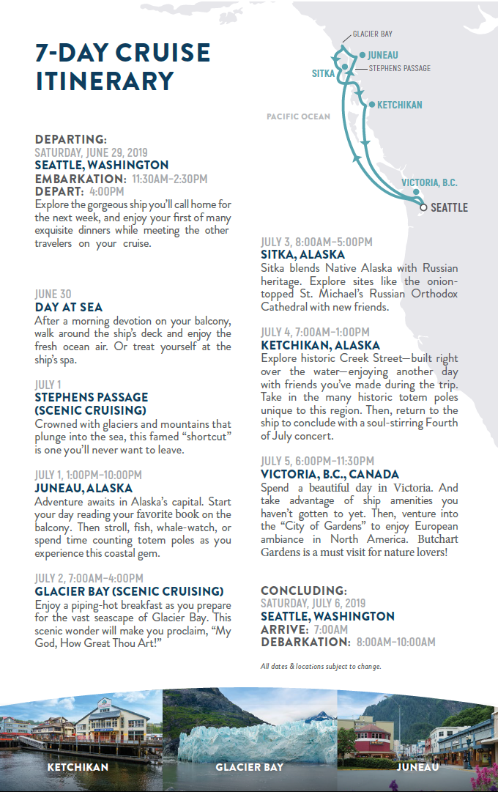

Subject: Alaska cruise

To: Milan

From: Adriana

Hi Milan,

Thank you for sending me the itinerary. It really helped us in making a decision for our family’s annual trip. My parents live in Squamish, which is about one hour away from Vancouver. It would be great if you can 1.______. My husband and I will go straight to the port with the children from our house in Seattle.

I noticed the cruise 2.______. I am a little bit worried that the children may get sea sick on the cruise, because we are spending the whole day at sea. I guess I’d better prepare for that. The good news is, my husband is very keen on 3._______ in Juneau. I heard Juneau has a fantastic coastal view. He wanted to go to Hawaii, but he had a change of mind after seeing the itinerary. I will also bring my camera to take pictures of the renowned church in 4._______. It is nice that they give us some time to 5._______ before we return to Seattle. Anyway, thank you so much for being so patient with us. We will drop by your office to make a payment.

Regards,

Adriana

**Questions**

1. Click here to enter text.

a. make a hotel reservation for them c. pay for their trip

b. prepare wheelchairs d. arrange a transportation for them

2. Click here to enter text.

a. starts from Victoria c. will not stop in Anchorage

b. make its first stop in Juneau d. will leave on Sunday

CELPIP Training © 2019 Presto English Learning  
 <https://www.youtube.com/prestoenglish>

3. Click here to enter text.

a. watching a concert c. getting a spa treatment

b. visiting the famous garden d. going for a walk

4. Click here to enter text.

a. Ketchikan c. Sitka

b. Juneau d. Victoria

5. Click here to enter text.

a. see the whale c. enjoy the facilities on the ship

b. buy souvenirs for friends and family d. admire the historic totem poles

6. What is Milan’s relationship to Adriana? Click here to enter text.

a. Adriana’s friend c. Adriana’s colleague

b. Adriana’s travel agent d. Adriana’s tour guide

7. What’s Adriana likely to be concerned about? Click here to enter text.

a. Not having enough time to sightsee c. Her children may experience motion sickness

b. Forgetting to bring her camera d. Traveling without her parents

8. How does Adriana’s husband probably feel about the trip? Click here to enter text.

a. Not happy c. Nervous

b. Excited d. Indifferent

CELPIP Training © 2019 Presto English Learning  
 <https://www.youtube.com/prestoenglish>

**EVALUATING OUR WRITING**

There will be times in the future when you need to review/proofread your own writing. I created this exercise to help you do that.

TOPIC: The school is proposing to make a French program required for all elementary school students.

The school is sending out a survey to parents to hear their opinions. You have two options:

A – Accept the proposal

B – Reject the proposal

**Read the paragraphs below**

A) As parent, I want my children to get the best education. These days, without good education it’s difficult for people to find employment. I don’t want my children to be in that situation, and I am sure other parents will say the same.

B) I can see the benefit of teaching french to young students. At that age, it is a lot easier for them to pick up a new language. Even though it’s important to learn a second language, but there are a lot of young adults who give up, because they find it difficult to memorize new vocabulary, learn the word pronunciations, or grasp the language structure. The earlier they start learning, the less obstacles they will have to face in learning a new language.

C) Secondly, the french language is particularly useful in canada. It doesn’t hurt the children to sharpen their French skills. They will thank us and the school later when they grow up. The modern world demands people to be able to speak two languages. Those who don’t keep up will be left behind.

D) Thank you for asking my opinion on this. I hope you make the right decision.

Go through the checklist below, and answer Yes or No. Write down your reasons, if you think the writing can be improved, explain how. **You can use this checklist with your own writing too.**

1. The writer’s opinion is clearly stated (Yes or No?)

Click here to enter text.

1. The writer included strong supporting details

Click here to enter text.

1. The ideas are related to the topic

Click here to enter text.

1. The writer has a proper closing paragraph.

Click here to enter text.

1. The writer tried to use vocabulary that’s not too general in writing the sentences.

Click here to enter text.

1. When I read it as the reader (not as the author); is it easy to understand?

Click here to enter text.

1. Is the grammar and spelling correct (including capitalization AaBbCc)?

Click here to enter text.

CELPIP Training © 2019 Presto English Learning  
 <https://www.youtube.com/prestoenglish>

**Read and study the expressions below.**

**You’d better (had better)**: used to give advice/suggestion

Possible use in the test: to give advice, difficult situation, opinions, persuade

You’d better go now, your girlfriend is waiting.

I’d better study, I don’t want to fail the exam.

I’d better withdraw some money, my landlord might kick me out if I don’t pay the rent.

**You’d be(would be) better off**: used to express an opinion regarding choicses

Possible use in the test: to give advice, difficult situation, opinions, persuade

You’d be better off living alone. You don’t need to share the bathroom.

You’d be better off working here. The pay is better than at the café.

He’d be better off breaking up with that girl.

**Gotta (Got to)**: the informal form of ‘have to’

Possible use in the test: to give advice, persuade, describe difficult situation, opinions

You gotta work hard if you want to succeed.

We gotta do this. This is a once in a life time opportunity.

I gotta go with my guts, even though I might disappoint you.

**In terms of/when it comes to**: used to indicate a topic of the sentence

Possible use in the test: to give advice, persuade, describe experience, difficult situation, opinions

In terms of the quality, Samsung is the best.

When it comes to the location, I prefer having the party at a hotel.

I don’t like the apartment in terms of the layout.

When it comes to money, I need to be careful.

**Come up with**: to think of

Possible use in the test: giving advice, experience (talking about a plan)

You should come up with a back-up plan.

Our family came up with an idea to open a restaurant.

**PRACTICE QUESTIONS**

Record your response to this topic and send your response in the Telegram group.

You can try to use the expressions above if you think it’s appropriate, but it’s not mandatory.

**You should practice your response multiple times, but send your best response.**

**Speaking Part 5**

**This task consists of 2x 60 seconds of preparation time and 1x 60 seconds of speaking time.**

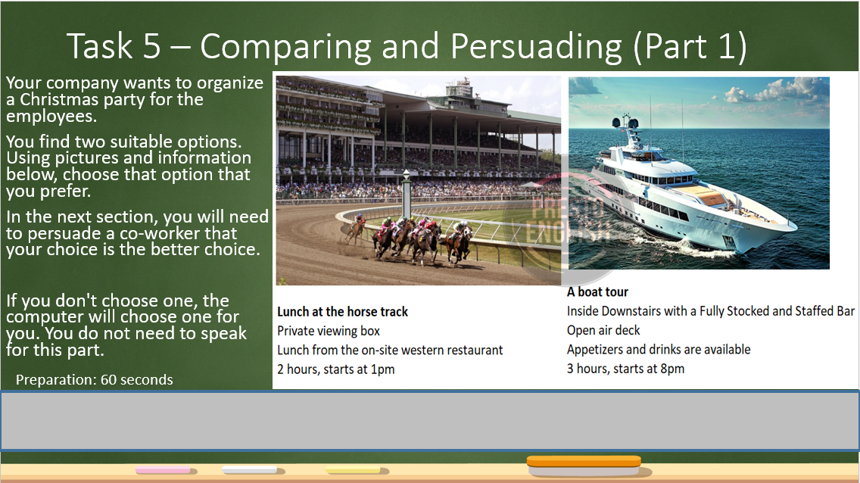

**(no speaking required for the picture above)**

**Go to the next page for your next slide**

**Use this if you choose the lunch at the horse track**

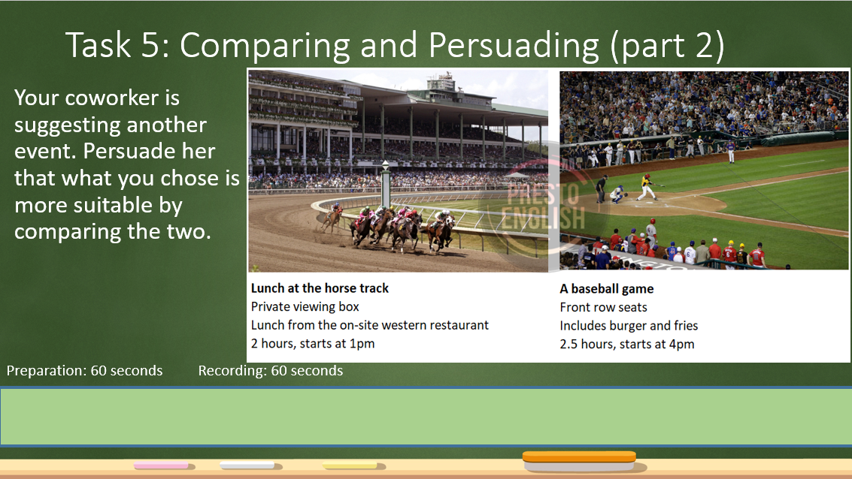

**Use this if you choose the lunch at the boat tour**

